Recruitment Information Pack

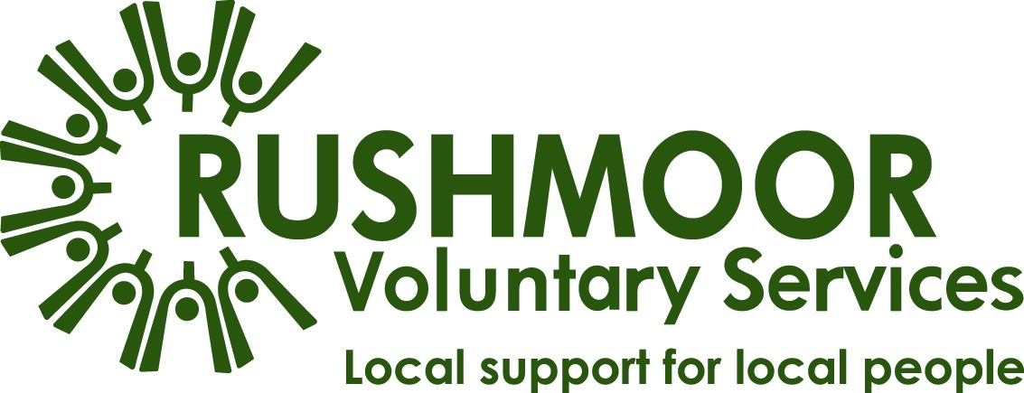

Membership Support Co-ordinator

To apply:
Please apply by sending your CV (including current salary) and a supporting statement to clair@vivohr.co.uk
Your statement should explain why you’d like the role, what you will bring to the organisation and how your skills and experience reflect those specified.
Your statement should be no longer than three pages.

For more information please see our Application Guidelines.

We will be assessing applications as we receive them and interviewing on a rolling basis. We may therefore close the recruitment at any time so we encourage you to submit your application as soon as possible.

Thank You!
Thank you for your interest in Rushmoor Voluntary Services (RVS). This information pack should provide all the information that you need but please don’t hesitate to contact our CEO, Donna Bone if you need further details on 07736 044495 or via ceo@rvs.org.uk.
We are also able to be flexible on some aspects of the role so we would encourage you to contact Donna if you would like to discuss the role or person specification in more detail.

About Us
Established as a registered charity in 1971, RVS are the Council for Voluntary Service (CVS) in Rushmoor. Our role in the community is to champion volunteering and to support any voluntary or community group working in the Borough of Rushmoor.

We support our members by creating networks; our well attended quarterly Voluntary Sector Forum is testament to this. We provide support with volunteer recruitment and training, plus maintaining good practice.

RVS manage a number of projects that provide community benefit. These include:
- Blooming Marvellous - a supported volunteering gardening project.
- Community Transport - which includes scheduled passenger services and a group-hire minibus scheme for Rushmoor & Hart.
- HIV in Hampshire - emotional and practicable support to people living with HIV.
- Home Help - providing shopping and light housework to frail, elderly and disabled people.

We work in close partnership with various organisations including our core funders Rushmoor Borough Council and Hampshire County Council.

RVS are members of the Hampshire Council of Voluntary Services (CVS) Network, an alliance of eight organisations who work together to help Hampshire’s charities, community groups and social enterprises to succeed and flourish. We collaborate in a local cluster with Hart and Basingstoke CVSs.

Our Mission
In partnership with the voluntary, statutory and business sectors, enabling all the people of Rushmoor to play a full and active part in the life of the local community.

Where we Work
The area we cover for our CVS services includes Aldershot and Farnborough, along the Blackwater Valley in the north east corner of Hampshire.

Over 350 organisations and groups from this area are members of RVS.

Many of our support services cover areas of Hart, something which we wish to proactively increase.

Since August 2019, our office has been within the Civic Offices alongside Rushmoor Borough Council and other key organisations supporting the community of Rushmoor.

Our Team
We began a period of significant change during 2019; our new Chief Executive Officer (CEO) and Community Development Manager (CDM) were appointed to replace their long-standing predecessors. We also moved away from the accommodation which has always been our base but has enabled us to work closer with our key stakeholder, Rushmoor Borough Council.

2020 presented opportunities for further change, partly due to the retirement of other key staff but also in response to our experiences during the Covid-19 emergency.

The current paid staff team comprises of various - mostly part-time - roles which are supported by a team of volunteers.
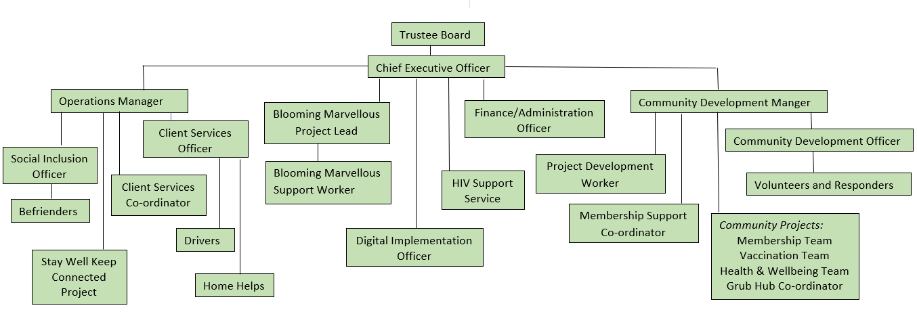

The Role
Our key role in leading and coordinating the local response to the Covid-19 emergency has reinforced our intention to change how we support our community. Operation Rushmoor Community Action (ORCA) successfully recruited and deployed almost 400 volunteer Responders. We have triaged the needs of vulnerable residents and delivered support in response to over 2,000 requests for help, to date.

To further those achievements, the aim of this new role is to support the community development approach to forming a Volunteer Hub, creating a first-rate service for our volunteers and member organisations. The role will improve our efficiency and bring the organisation into the 21st century.

The main aim of the role is to provide a strong administration support to our Community Development team and to the membership of RVS. Reporting to the CDM, you will support the team by:

- administering support and communications, and
- facilitating the delivery of resources to benefit the local voluntary sector.

You will work 21 hours per week, the majority of this will be during traditional office hours but you may occasionally be required to be available outside of these hours.

The Benefits
As well as working in a long established and community focussed organisation, you will be based in a new office environment with generous facilities (subject to Covid restrictions). Some home working will be available as we transition to hybrid arrangements.

We offer:
- A permanent contract. This is subject to funding and satisfactory completion of a six month probationary period.
- A salary of circa £11,500 according to relevant experience.
- Auto enrolment in the company's defined contribution pension scheme. Individual contributions are flexible subject to statutory minimum and maximum limits; RVS contributions will be paid in accordance with policy.
- Mileage and out-of-pocket expenses undertaken on behalf of RVS, paid in accordance with the Inland Revenue mileage rates for business travel, e.g. 45p per mile for travel by car.
- 20 days paid annual leave rising to 25 after five years’ service, plus statutory days, pro-rata.
- An incrementally increasing period of sick pay in accordance with length of
service.
- Free parking during working hours.

Job Description
Whilst the overarching aim of this role will remain, the specific responsibilities will be reviewed in line with the strategic development of the organisation.

Administration
- Support the development and implementation of a new CRM, incorporating the membership database.
- Maintain accurate details of members and stakeholders on the CRM.
- Identify potential members and support their engagement with RVS.
- Receive and process membership applications in a timely manner.
- Work with the CDM and other relevant staff to provide timely reports for the Board of Trustees and project funders and contractors, including performance data for individual projects and staff activities.
- Provide admin support and back up to the Community Development Team including the Volunteer Hub.
- Attend team meetings and take notes.

Membership Support Services
- Provide information, advice and support to member organisations on new and existing initiatives.
- Promote and facilitate DBS checks.
- Organise and promote the quarterly Voluntary Sector Forum (VSF), AGM and other opportunities for community engagement and cross sector networking.
- Administer the bookings, minutes and other actions resulting from the VSF and AGM.
- Research speakers and trainers for the development of a training programme in response to members’ needs.
- Facilitate the promotion, bookings and delivery of the training programme.

Communications
- Provide a first point of contact for general enquiries from members, individuals and the public.
- Provide information or signpost members and enquirers to the appropriate resource to meet their need.
- Support individuals to access volunteering through our sign up systems.
- Receive, collate and disseminate information of value and interest to members via newsletters and bulletins.
- Receive, collate and disseminate news from members, in conjunction with the Community Development Officer.
- Prepare information to be disseminated via the social media team.
- Assist with the production and distribution of newsletters, bulletins, social media and communication with the sector and with volunteers.
- Facilitate the booking of, and access to resources which members are able to utilise, eg gazebos, display stands etc.
- Support the marketing of the organisation.

General
- Provide some cover for Community Development Officer when absent. This will necessitate an understanding of the CDO role.
- Support good internal communications and a positive working environment.
- Maintain good working relations with key individuals and other organisations within the voluntary, statutory, public and business sectors active within Rushmoor.
- If required, provide administrative support to the CEO and CDM in situations of increased workload or staff absence.
- Undertake other duties as requested by the CDM that are commensurate with the post and the development of the organisation.
- Promote equality and diversity in all undertakings.
- In all undertakings ensure compliance with RVS policies.

Priorities for the first six months
- Update contact details and data on membership groups being captured by the ORCA Membership Team.
- Undertake data cleansing checks before beginning the data population of the CRM.
- Working with the CDM, support the delivery of the plan to respond to the emerging needs of the local voluntary sector to recover from the impact of covid restrictions.
- Organise and co-ordinate the delivery of MiDAS refresher training to drivers with covid lapsed licences.
- Organise and co-ordinate the delivery of First Aid training for our Members.
- Support the plan for retaining and deploying volunteers recruited through ORCA.
- Provide support to the 50th anniversary activities.

Priorities for the following six months
- Promote the revised membership offer wider across the voluntary sector in Rushmoor.
- Continue to develop training and networking opportunities for Members.

About You
You will be educated to a high standard, have strong administrative and possess excellent organisation and IT skills.
You will possess a positive, ‘can do’ manner, be approachable and respectful with excellent customer service skills.

Values and Aptitude
Essential
- Ability to develop good working relationships with colleagues at all levels, in a range of organisations.
- Able to monitor and maintain own standards.
- Ability to work on own initiative, prioritise and meet deadlines.
- Methodical and effective approach to work, with attention to detail, and good time management.
- Flexible approach and willingness to work as part of a team with ability to make positive contributions to benefit the whole organisation.
- Demonstrate an inclusive mind-set.
- Be open to change.

Desirable
- Proven interest in supporting the Rushmoor community.

Education, Administration and Communication
Essential
- Educated to a minimum of GCSE level including English and Maths A*-C.
- A good administrator and able to multi task and prioritise workload.
- Good communication skills, both written and verbal.
- Strong attention to detail.
- Ability to communicate clearly and concisely, both orally and in writing.
- Demonstrable organisation skills and the ability to manage a varied workload and to prioritise.

Desirable
- Degree in relevant topic or volunteer management qualification.

IT Skills
Essential
- Excellent IT skills – Microsoft Office. Primarily this will entail the extensive use of Outlook, Excel and Word.
- Understanding and ability to facilitate online meetings.
- A good understanding of CRM databases – training will be provided for the RVS systems.

Desirable
- Knowledge of Office 365 and Sharepoint.
- Ability to create publicity material.
- Ability to navigate and create content for websites and social media.

Information Governance
Essential
- Understanding of GDPR.

Voluntary Sector Knowledge
Desirable
- Experience of volunteering or working with volunteers.
- Experience of supporting voluntary organisations and/or community groups.

