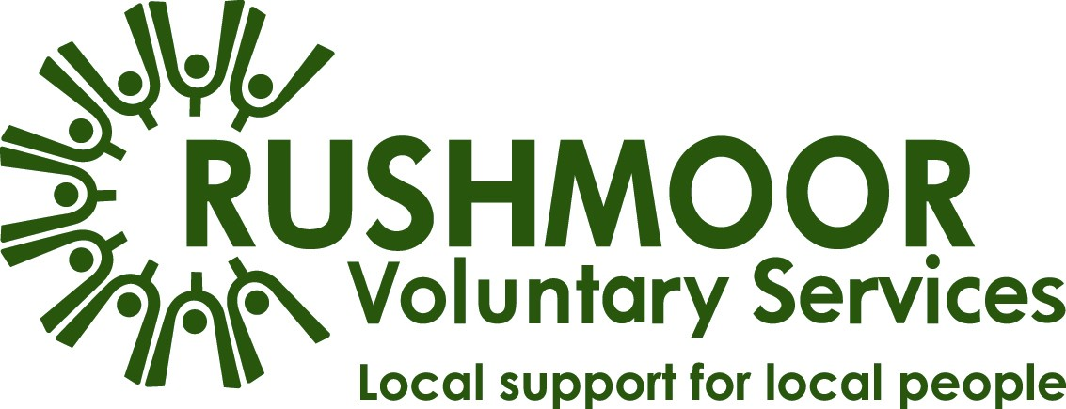

Operation Rushmoor Community Action (ORCA) Volunteering Guidelines

We live in challenging times and are responding to the new environment we find ourselves in. The covid-19 pandemic now threatens the parts of our local community that we normally support, so we have stepped up to face the challenge.

We have not had a ‘call to arms’ on this scale since World war II and the local response has been amazing - Thank You!

Rushmoor Voluntary Services (RVS) is working with Rushmoor Borough Council (RBC) to co-ordinate Operation Rushmoor Community Action (ORCA). This is the local response to the Coronavirus (covid-19) situation.

We are in contact with voluntary groups across the Borough who are offering support and we are:
- mapping the services which are still being run,
- identifying the new services offered to support Rushmoor residents,
- recruiting Responders (volunteers) and matching them with groups and services that need support,
- offering information and support via the ORCA helpline.

Volunteering Opportunities
Thank You! You and hundreds of other people have offered time and skills just when we need it most.

Now that you have completed your application and we are undertaking a reference, we need you to complete some basic training before you become registered with RVS as a Responder.

Once completed we will invite you to respond to opportunities to support ORCA activities or to organisations being delivered by or with other groups to meet the increased demand on their service.

Whilst your help and support will be invaluable at this time, it is important not to overdo things. We would encourage you to start by undertaking one or two ‘shifts’ or tasks initially so that you can experience what is involved before committing.

From then, we - or the groups you support - will be relying on you to be available for when you have committed. If you become unwell, your circumstances or availability changes then please contact your Co-ordinator as soon as possible.

It is also vitally important that you only take on tasks which you are happy to do and feel comfortable and skilled to do; it’s perfectly fine to say ‘no’! There are plenty of activities so we will find something that suits you.

We will be seeking support for various roles in the community including:
- marshalling at the vaccination stations,
- shopping for food and/or other essentials,
- collecting and delivering prescriptions,
- providing transport to move equipment and resources,
- gardening or taking bins out/recycling.

Please be aware that an increasing number of people we are supporting will be self-isolating due to Test and Trace. Some households will be isolating due to testing positive or having covid-19 symptoms. Please follow the guidelines below or contact RVS if you do not wish to support these households.

There are other roles which you may be able to undertake if you are not able to volunteer in the community but can do so from home including:
- telephony or online befriending,
- ‘checking in’ to ensure people are safe and well,
- helping people access other services and help they may require,
- administrative support roles to coordinate Responders, ensuring appropriate records are kept,
- publicising and promoting the activities and services.

Please note this is not a definitive list and there will be many ways Responders will be making a difference to people’s lives and no matter how small, this contribution is important. As an ORCA Responder you will very likely be supporting older or vulnerable people, so our aim is to keep you and the people you are supporting as safe as possible.
Under no circumstances should you enter anyone’s house, undertake any personal care for anyone or offer any health advice. Direct people to the Government and NHS guidelines – links can be found at the bottom of this page.

RVS Responders
As an RVS Responder, we are able to support you in various ways. We are available to offer general guidance on your volunteering experience and to support you if you have any concerns or questions. Please contact RVS on 01252-398450 or via volunteering@rvs.org.uk.

Support Team
The welfare of our Responders is of paramount importance and as such we have a team of people available to support you, including:

Welfare Supporters who will be available to talk with you if you have had an experience which has upset you or left you feeling as if you need to talk about it with someone.

Safeguarding Leads who will be able to advise or receive your concerns about individuals with regard to their safety or wellbeing.

GDPR Leads will be able to respond to enquiries about personal data, its storage, use and erasure.

Insurance
As an RVS Responder, you are covered by our public liability insurance, but only for tasks that you are authorised to do. All RVS Responders are required to carry out their role in a safe manner.

You will need to inform your insurance company if you intend to be driving in a voluntary capacity. There should not be an additional cost to you but if there is, we are unable to pay expenses. You would therefore need to meet the cost yourself or not use your vehicle whilst volunteering.

Travel Expenses
Due to the high volume of individuals accessing support from Responders we are unable to cover Responder expenses, e.g. travel. We advise reducing the cost of volunteering by doing errands and shopping for local residents when you are doing your own shopping etc.

Staying Well
Due to the nature of covid-19 we are asking only people who are physically well and able to carry out tasks to volunteer in the community. As much as you may wish to help please do not, under any circumstances volunteer outside of your home, if you should be self-isolating. This means if you or someone you live with has or develops any symptoms including a temperature, persistent cough or other flu like symptoms, or you are in one of the high-risk categories.

For those who are able to volunteer in the community you must always follow social distancing requirements and take all the precautions you can to reduce social interaction between you and other people including:

- avoid contact with anyone who is displaying symptoms of covid-19,
- always comply by social distancing rules from other people when outside your home. Check https://www.gov.uk/coronavirus for up to date information,
- avoid non-essential use of public transport,
- use telephone or online services to contact your GP, 111 or other essential services.

Please remember, no matter what role you volunteer for outside of your home, you must:
- not continue to volunteer If you become unwell. You need to protect yourself and not put other people at risk,
- wash your hands with soap and water for at least 20 seconds before volunteering,
- take sanitiser gel with you and use regularly when you don’t have access to soap, water and washing facilities,
- wear a face covering in public spaces and when volunteering,
- always wash your hands when you get home from volunteering,
- cover your mouth and nose with a tissue or your sleeve (not your hands) when you cough or sneeze,
- put used tissues in the nearest bin immediately and wash your hands afterwards,
- do not touch your eyes, nose or mouth if your hands are not clean,
- maintain social distancing of two metres.

Sickness Reporting
Please notify RVS or the group you are volunteering for as soon as possible if you become unwell, have symptoms of covid-19 or are asked to self-isolate through NHS Test and Trace. Keep us informed of your progress and expected date of return as this will enable cover to be arranged.

Emergency and First Aid

All accidents should be reported to RVS as soon as is practically possible so we can keep a record.

Health & Safety
Assessing risk is something we all do every day, for example when you look where you are going whilst walking down the street to avoid tripping or bumping into things. It is a method of assessing the risks and hazards in certain situations and the safety measures which should be put in place to minimise these risks whilst volunteering.

The Health & Safety at Work Act lays down certain duties on all individuals operating within an organisation. In particular, you have a duty to:

- work/volunteer safely, efficiently and without endangering the health and safety of yourself, your colleagues or the general public,
- report all accidents, near miss occurrences and hazardous situations to RVS.

As a general rule, if you feel unsafe whilst volunteering you must tell the co-ordinator or RVS immediately.

Whilst doing activities such as shopping and lifting bags and boxes or moving recycling bins or gardening, remember to be safe when manual handling to ensure that your health and safety is not put at risk.

Safeguarding
Safeguarding is about creating a safe environment, where everyone is respected and valued. It’s about making sure those working or volunteering do so in a way that actively prevents harm, harassment, bullying, abuse and neglect. It’s also about being ready to respond safely and well if there is a problem.

When supporting older people or vulnerable people, it is best to telephone them before you visit, if possible, to find out what help they may need and tell them when you will be visiting. This also helps to minimise any social interaction and maintains the Government guidelines. You should be particularly mindful of:

- the person you are helping becoming anxious/aggressive,
- the individual is more confused than normal,
- there are potential safeguarding issues.

If you have any concerns about an individual you are supporting you should report it to your co-ordinator or to RVS who will provide support with safeguarding concerns and inform the proper authorities.

However, if you feel the need to immediately report signs of abuse or the potential risk of abuse phone Hampshire Adult Services on 0300 555 1386 or the police on 101. In an emergency, or if you suspect you or someone else is in immediate danger, phone 999.

Legislative Compliance
You will become aware of the personal circumstances of some individuals which you are required to keep confidential.
You will need to obtain consent from individuals to collect any personal data; this may be given verbally.
Ensure that any notes you take whilst ‘on duty’ are shredded/destroyed once they have served their purpose.
Code of Conduct
As good as your intentions may be, please do not share your personal numbers, email address, social media details etc – once you have shared this, you have no control over its dissemination or its use. If communication is needed please take the contact detail for the individuals needing support and co-ordinate this through your co-ordinator or RVS.

Please do not offer to lend, give, ask to or borrow money from the individuals you are supporting. Also, do not accept gifts or payment how ever well intentioned it is. If individuals wish to express gratitude, encourage them to formally donate to your local group or to RVS.

Please be mindful that most people are feeling some level of anxiety around the covid-19 situation so please interact with colleagues, the public and all third parties with courtesy at all times. This includes being aware of sensitive areas such as politics, faith, culture, sexuality and disability.

Your Welfare
We are committed to ensuring the welfare of our wider team. Please ensure that you only commit to do what you can comfortably do. Take regular breaks and ask for support when needed.

Please contact RVS if you need any information or support on 01252-398450 or via volunteering@rvs.org.uk.

When this is all over…
You might like to consider continuing volunteering. At the moment we are focussed on supporting people though the covid-19 situation but ordinarily there are hundreds of local groups needing support. When the time comes, please contact RVS on 01252-398450 or via volunteering@rvs.org.uk to discuss other opportunities.

Advice on covid-19
Please ensure that you continue to follow guidelines to protect your own health.

Hampshire County Council is publishing regular updates and sharing public health and government guidance updates on its dedicated web-pages -
https://www.hants.gov.uk/coronavirus

Direct links to GOV.UK guidance are available here -
https://www.gov.uk/coronavirus and https://www.gov.uk/government/publications/coronavirus-how-to-help-safely--2/coronavirus-how-to-help-safely

