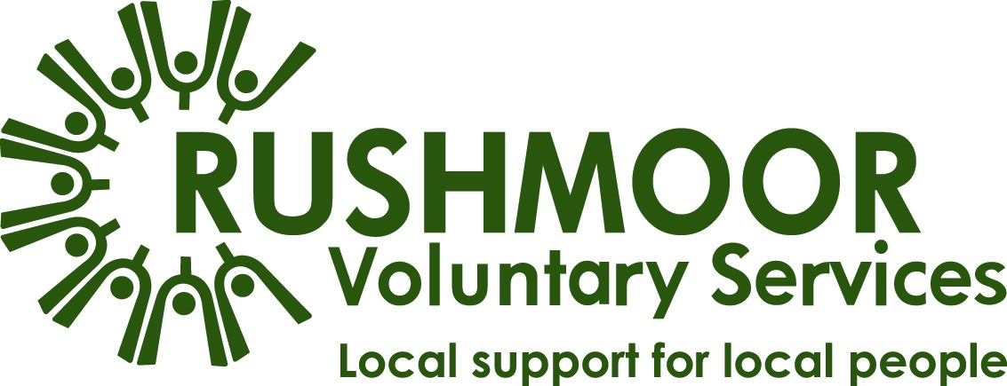
About Us
Established as a registered charity in 1971, RVS are the Council for Voluntary Service (CVS) in Rushmoor. Our role in the community is to champion volunteering and to support any voluntary or community group working in the Borough of Rushmoor.

We support our members by creating networks; our quarterly Voluntary Sector Forum is regularly attended by approximately 100 individuals. We also provide support with recruiting for volunteers and with achieving good practice.

RVS also manage a number of projects that provide community benefit. These include:
- Blooming Marvellous - a supported volunteering gardening project.
- Community Access Project – mental health support.
- Community Transport - which includes scheduled passenger services and a group-hire minibus scheme for Rushmoor & Hart.
- HIV in Hampshire – emotional and practicable support to people living with HIV.
- Home Help - providing shopping and light housework to frail, elderly and disabled people.

We work in close partnership with various organisations including our core funders Rushmoor Borough Council and Hampshire County Council.
RVS are members of the Hampshire CVS Network, an alliance of 10 local organisations who work together to help Hampshire’s charities, community groups and social enterprises to succeed and flourish, and collaborate in a local cluster with Hart and Basingstoke CVS.

Our Mission
In partnership with the voluntary, statutory and business sectors, enabling all the people of Rushmoor to play a full and active part in the life of the local community.

Where we Work
The area we cover for our CVS services includes Aldershot, North Town, Farnborough, North Camp, Cove and Blackwater Valley in the north east corner of Hampshire.

Over 350 organisations and groups from this area are members of RVS.

Many of our support services are delivered in areas of Hart which, in conjunction with Hart Voluntary Action, we wish to proactively increase.

Since August 2019, our office has been within the Civic Offices alongside Rushmoor Borough Council and other key organisations supporting the community of Rushmoor.

Our Team
We went through a period of significant change during 2019; our new CEO - appointed to replace her long-standing predecessor - also managed our office move. This took us away from the accommodation which has always been our base but has enabled us to work closer with a key stakeholder – Rushmoor Borough Council – by sharing their building.

The new Community Development Officer was appointed in August, due to the retirement of the previous staff member who has been with us for 16 years and we have additional retirements planned for this year.

2020 is also presenting opportunities for further change, partly in response to our experiences during the Covid19 emergency. Our key role in leading and co-ordinating the local response to the Covid-19 emergency has reinforced our intention to change how we support our community. Operation Rushmoor Community Action (ORCA) successfully triaged the needs of residents and delivered support in response to requests for help by working in a hub model in partnership with mutual aid groups and supported by volunteers.

The Role
The overall role of a Treasurer is to maintain an overview of the organisation’s affairs, ensure its financial viability and ensure that proper financial records and procedures are maintained.

In addition to the general responsibilities of a trustee, duties of the treasurer include the following.
- Overseeing, approving and presenting budgets, accounts and financial statements
- Being assured that the financial resources of the organisation meet its present and future needs
- Ensuring that the charity has an appropriate reserves policy
- Preparing and presenting financial reports to the board
- Ensuring that appropriate accounting procedures and controls are in place
- Liaising with any paid staff and volunteers about financial matters
- Advising on the financial implications of the organisation’s strategic plans
- Ensuring that the charity has an appropriate investment policy
- Ensuring that there is no conflict between any investment held and the aims and objects of the charity
- Monitoring the organisation’s investment activity and ensuring it is consistent with the organisation’s policies and legal responsibilities
- Ensuring that the accounts are prepared and disclosed in the form required by funders and the relevant statutory bodies, for example the Charity Commission and/or the Registrar of Companies
- If external scrutiny of accounts is required, ensuring that the accounts are scrutinised in the manner required (independent examination or audit) and any recommendations are implemented
- Keeping the board informed about its financial duties and responsibilities
- Contributing to the fundraising strategy of the organisation
- Making a formal presentation of the accounts at the annual general meeting and drawing attention to important points in a coherent and easily understandable way
- Sitting on appraisal, recruitment and disciplinary panels as required

Person Specification
- A commitment to the organisation and to the community
- A willingness to devote the necessary time and effort
- Strategic vision
- Good, independent judgement
- An ability to think creatively
- A willingness to speak their mind
- An understanding and acceptance of the legal duties, responsibilities and liabilities of trusteeship
- An ability to work effectively as a member of a team
- A commitment to Nolan’s seven principles of public life: selflessness, integrity, objectivity, accountability, openness, honesty and leadership.

In addition to the person specification for a trustee - above - the treasurer should have the following qualities:
- Financial qualifications and experience
- Some experience of charity finance, fundraising and pension schemes
- The skills to analyse proposals and examine their financial consequences
- Being prepared to make unpopular recommendations to the board
- A willingness to be available to staff for advice and enquiries on an ad hoc basis

